ADDENDUM NO. 4

Landscape Services at Various Park Facilities

March 13, 2023

This Addendum form is a part of the Contract Documents for the above-identified project and modifies the original Specifications and Contract Documents, as noted on the following pages. Portions of the Contract, not specifically mentioned in this Addendum, remain in force. All trades affected shall be fully advised of these changes, deletions, and additions.

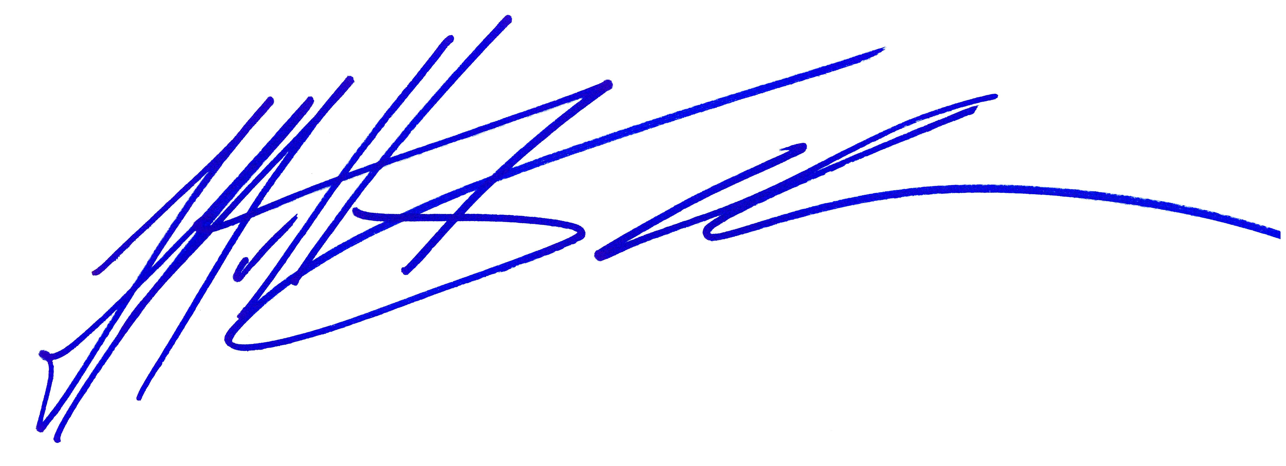
The proposal due date is 5:00pm on March 17, 2023.

_____________________________
Matt Kouba
Park Superintendent
Conejo Recreation and Park District

PROPOSER’S CERTIFICATE

I acknowledge receipt of all three (3) pages of this Addendum No. 4 and accept the aforementioned.

________________________________________ ________________________
Proposer’s Signature Date
THIS DOCUMENT TO BE SIGNED
AND SUBMITTED WITH PROPOSAL
Landscape Services at Various Park Facilities

March 13, 2023

ADDENDUM NO. 4

The following additions and/or corrections shall become a part of the Contract Documents and Specifications for the above named project. When submitting a proposal for the project, this Addendum shall be acknowledged and a signed copy of the Addendum shall be included in the proposal package.

Changes or clarifications are noted are BOLD and UNDERLINED

I. GENERAL

The proposer is directed to make the following corrections, deletions, and/or additions to the contract documents and contract drawings heretofore dispensed to him for the above project, and to note proposer’s receipt of this addendum by number on the attached Addenda Acknowledgement Form:

MODIFICATIONS TO PREVIOUS ADDENDA

N/A

III. PROPOSAL AND CONTRACT REQUIREMENT REVISIONS
N/A.

V. RFI
- What is the name of the current contractor?
  - Please see Addendum #2
- Are there any changes in the current scope of work and the and last time it was out for bid?
  - Yes, there are additional parks and there are tweaks to the services.
- How Long has the current incumbent had the contract?
  - Please see Addendum #2
- What is the monthly invoice for the is contract?
  - Please see Addendum #2
- Who pays for Irrigation Parts?
  - Please see Exhibit B of the RFP Exhibit B Section #12
- What is the tree maintenance requirements ?
  - Please see Exhibit B of the RFP Exhibit B Section #3
- Is Roundup ok to use in you city?
  - Please see Addendum #3 question #2
- Is storage provided on city property for contractors equipment?
  - No.
- Does contractor pay for disposal or city?
  - Daily waste can be disposed of at Park District rubbish and greenwaste bins located at Waverly Equestrian Center.
- Is a bid bond required?
  - No

- RFP states mowing 1x week in growing season. How many mows were completed last year for this contract. Was the winter months done 2x monthly?
  - Please see Exhibit B of the RFP Exhibit B Section #1. Mowings were completed in accordance with contract.

When submitting a proposal for the project, this Addendum shall be acknowledged and a signed copy of the Addendum shall be included in the proposal package

