ADDENDUM NO. 2

Landscape Services at Various Park Facilities

March 6, 2023

This Addendum form is a part of the Contract Documents for the above-identified project and modifies the original Specifications and Contract Documents, as noted on the following pages. Portions of the Contract, not specifically mentioned in this Addendum, remain in force. All trades affected shall be fully advised of these changes, deletions, and additions.

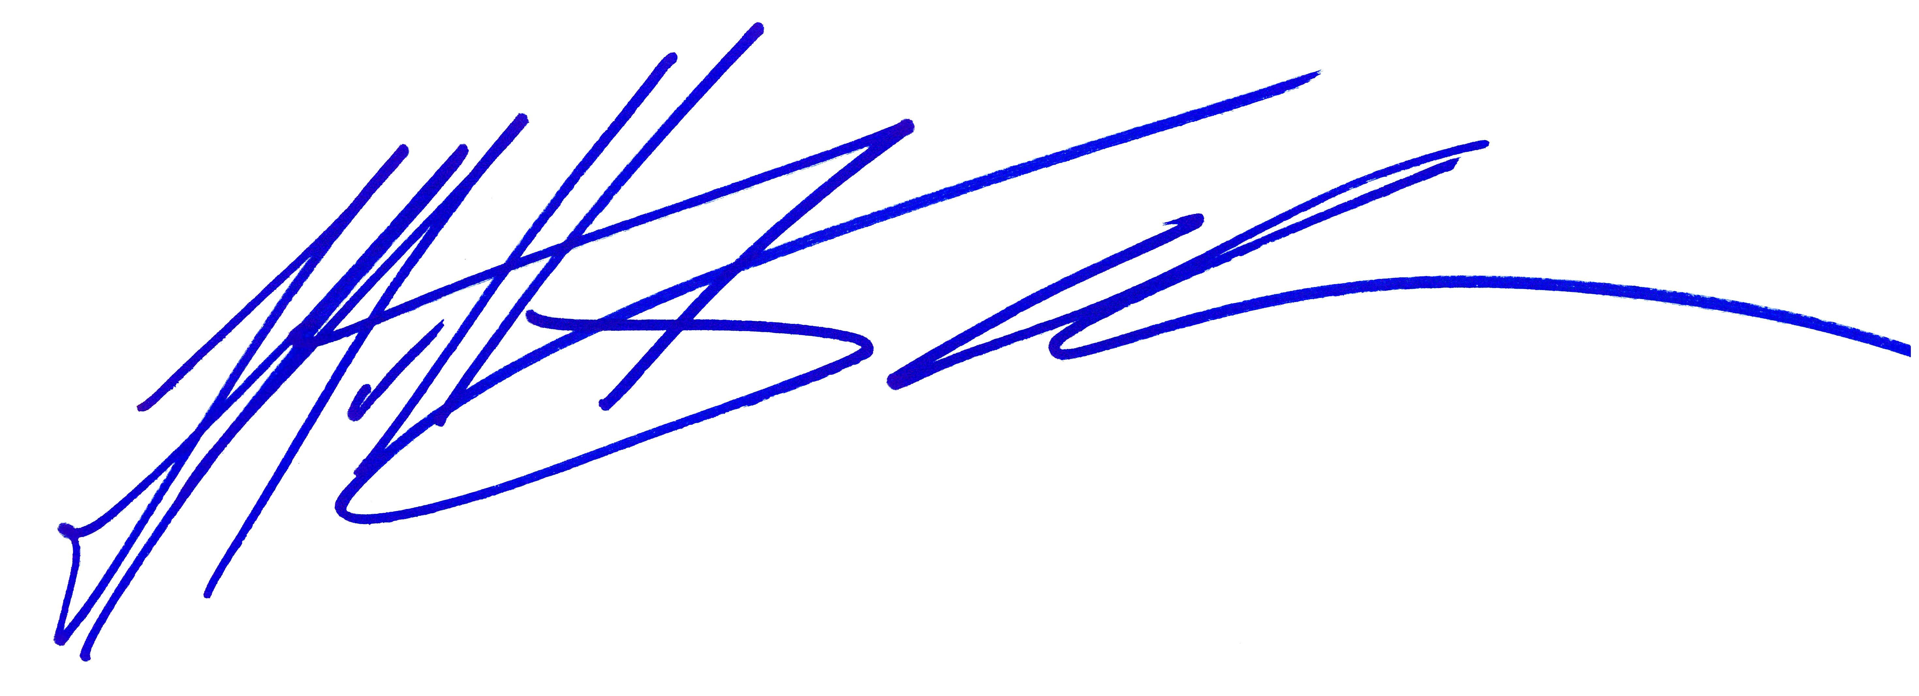
The proposal due date is 5:00pm on March 17, 2023.

_____________________________
Matt Kouba
Park Superintendent
Conejo Recreation and Park District

PROPOSER’S CERTIFICATE

I acknowledge receipt of all Two (2) pages and two (2) attached PDF one titled “2011 1117 Natural Green Contract for Temporary Services” and the other “2022 1117 Venco Western Contract for Temporary Services” of this Addendum No. 2 and accept the aforementioned.

________________________________________ ________________________
Proposer’s Signature Date
THIS DOCUMENT TO BE SIGNED
AND SUBMITTED WITH PROPOSAL
Landscape Services at Various Park Facilities

March 6, 2023

ADDENDUM NO. 2

The following additions and/or corrections shall become a part of the Contract Documents and Specifications for the above named project. When submitting a proposal for the project, this Addendum shall be acknowledged and a signed copy of the Addendum shall be included in the proposal package.

Changes or clarifications are noted are BOLD and UNDERLINED

I. GENERAL

The proposer is directed to make the following corrections, deletions, and/or additions to the contract documents and contract drawings heretofore dispensed to him for the above project, and to note proposer’s receipt of this addendum by number on the attached Addenda Acknowledgement Form:

MODIFICATIONS TO PREVIOUS ADDENDA

N/A

III. PROPOSAL AND CONTRACT REQUIREMENT REVISIONS
N/A.

V. RFI
“I was wondering if there is a way for you to send me the current contract.”

Answer:
Attached are the two current temporary contracts. Background history – the previous contractor was unable to finish the contract through fiscal year 2022/2023. We met with Venco Western and Natural Green in an emergency to provide landscape maintenance through June 2023. By splitting the Park District Properties in half we were able get the proper services from these two companies. Please note these contracts were temporary in nature and do not represent a 5 year contract as per the RFP.

See Attached:

When submitting a proposal for the project, this Addendum shall be acknowledged and a signed copy of the Addendum shall be included in the proposal package

