ADDENDUM NO. 1

Landscape Services at Various Park Facilities

February 28, 2023

This Addendum form is a part of the Contract Documents for the above-identified project and modifies the original Specifications and Contract Documents, as noted on the following pages. Portions of the Contract, not specifically mentioned in this Addendum, remain in force. All trades affected shall be fully advised of these changes, deletions, and additions.

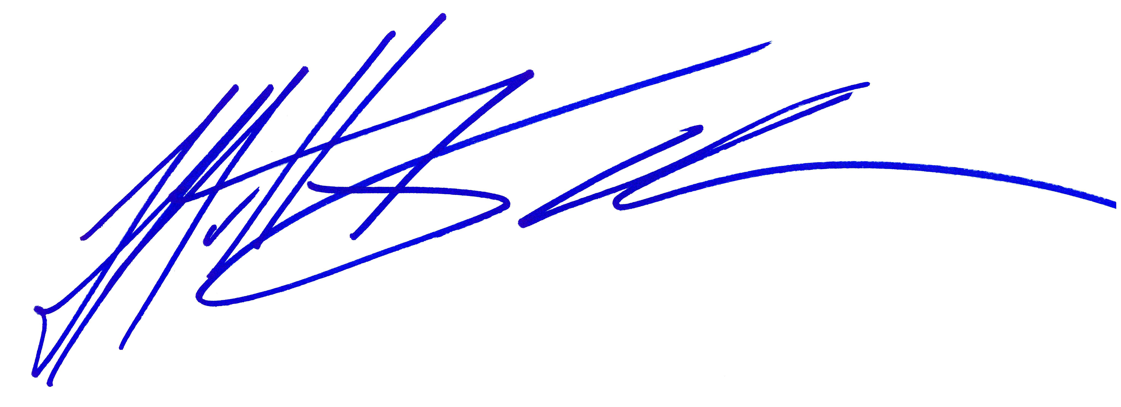
The proposal due date is 5:00pm on March 17, 2023.

_____________________________
Matt Kouba
Park Superintendent
Conejo Recreation and Park District

PROPOSER’S CERTIFICATE

I acknowledge receipt of all two (2) pages of this Addendum No. 1 and accept the aforementioned.

________________________________________ ________________________
Proposer’s Signature Date
THIS DOCUMENT TO BE SIGNED
AND SUBMITTED WITH PROPOSAL
Landscape Services at Various Park Facilities

February 28, 2023

ADDENDUM NO. 1

The following additions and/or corrections shall become a part of the Contract Documents and Specifications for the above named project. When submitting a proposal for the project, this Addendum shall be acknowledged and a signed copy of the Addendum shall be included in the proposal package.

Changes or clarifications are noted are BOLD and UNDERLINED

I. GENERAL

The proposer is directed to make the following corrections, deletions, and/or additions to the contract documents and contract drawings heretofore dispensed to him for the above project, and to note proposer’s receipt of this addendum by number on the attached Addenda Acknowledgement Form:

MODIFICATIONS TO PREVIOUS ADDENDA

N/A

III. PROPOSAL AND CONTRACT REQUIREMENT REVISIONS
N/A.

V. RFI

I wanted to reach out to see if Paige Lane Park has been completed as per the concept plan (except for turf)? Also, how many years ago are prices listed on Exhibit D?

Answer:

- Paige Lane has been completed except for the turf, the areas should be sodded at some point this year.
- The prices listed on Exhibit D are from the approved extension of the previous contract as of July 1, 2022

When submitting a proposal for the project, this Addendum shall be acknowledged and a signed copy of the Addendum shall be included in the proposal package

