ADDENDUM NO. 1

Custodial Services at Various Park Facilities

March 8, 2023

This Addendum form is a part of the Contract Documents for the above-identified project and modifies the original Specifications and Contract Documents, as noted on the following pages. Portions of the Contract, not specifically mentioned in this Addendum, remain in force. All trades affected shall be fully advised of these changes, deletions, and additions.

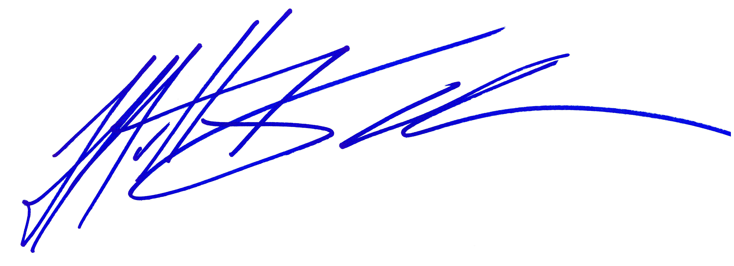
The proposal due date is 5:00pm on March 16, 2023.

_____________________________
Matt Kouba
Park Superintendent
Conejo Recreation and Park District

PROPOSER’S CERTIFICATE

I acknowledge receipt of all four (4) pages of this Addendum No. 1 and accept the aforementioned.

________________________________________ ________________________
Proposer’s Signature Date
THIS DOCUMENT TO BE SIGNED
AND SUBMITTED WITH PROPOSAL
Custodial Services at Various Park Facilities

March 8, 2023

ADDENDUM NO. 1

The following additions and/or corrections shall become a part of the Contract Documents and Specifications for the above named project. When submitting a proposal for the project, this Addendum shall be acknowledged and a signed copy of the Addendum shall be included in the proposal package.

Changes or clarifications are noted are BOLD and UNDERLINED

I. GENERAL

The proposer is directed to make the following corrections, deletions, and/or additions to the contract documents and contract drawings heretofore dispensed to him for the above project, and to note proposer’s receipt of this addendum by number on the attached Addenda Acknowledgement Form:

MODIFICATIONS TO PREVIOUS ADDENDA

N/A

III. PROPOSAL AND CONTRACT REQUIREMENT REVISIONS

Correction to Exhibit A pages A-20 through A-22 that corrects the flooring identification and care for the facility’s racquetball court and multi-purpose classroom as detailed below.

V. RFI

1. Will the Conejo Recreation and Parks District require bidders to submit evidence of good
standing in the form of an official certificate of good standing issued by the California,,
Secretary of State?
RESPONSE: This is not a requirement of the proposal, however it is up to the proposer to meet any federal, state or local agency requirements for the work provided as part of the proposal.

2. Will the Conejo Recreation and Parks District consider requiring a payroll tax and
workers compensation insurance audit, to ensure that potential service providers are
meeting all state and federal regulations?
RESPONSE: This is not a requirement of the proposal, however it is up to the proposer to meet any federal, state or local agency requirements for the work provided as part of the proposal.

3. Can the Conejo Recreation and Parks District clarify the exact flooring areas for both the
Thousand Oaks Community Center and Conejo Community Center that require the
specialized floor cleaning as outlined on pages A-9 and A-22?
RESPONSE:
- TO Community Center’s Multi-Purpose Classroom has 730 square feet of SPORT COURT RESPONSE HG (COATED FLOOR)
- Conejo Community Center’s Main Hall Multi-purpose has 2,800 square feet of SPORT COURT RESPONSE HG (COATED FLOOR)
- See attached addendum to the RFP

4. Can Conejo Recreation and Parks District clarify why the insurance requirement is set at
$5,000,000.00?
RESPONSE: This is the newer requirement from our insurance company.

5. Can the Conejo Recreation and Parks District confirm that hard surfaces like concrete
and tile do not require the strip and wax service to be performed, instead performing
power scrubbing of these surfaces.
RESPONSE: Concrete, porcelain ceramic and natural tile flooring and base do NOT require strip and wax service, they should receive sweeping, wet mopping and machine scrubbing only.
6. What contractor license is being referred on page 12 of the RFP/Q item # 4?
RESPONSE: This was included as a catch all for any licensing that might be required, however at this point in time the only licensing is a business license.

7. Can the Conejo Recreation and Parks District clarify if the pricing that should be
provided will be based on a one year rate, or will the pricing be locked on the term of the
contract?
RESPONSE: The pricing is for 5 individual years with two extensions – of course negotiations may take place with documentation and cause.

The following is a correction to Exhibit A pages A-20 through A-22 that corrects the flooring identification and care for the facility’s racquetball court and multi-purpose classroom.

CRPD Janitorial Service Contract Thousand Oaks Community Center
2525 N. Moorpark Rd. Thousand Oaks, CA 91360

DAILY - 7X PER WEEK

LOBBY/RECEPTION AREA
  - Vacuum/sweep all floor areas.
  - Dust and or clean all horizontal surfaces.
  - Spot clean glass entrance doors - each visit.
  - Sweep and mop tile floors.
  - Clean window sills.
  - Remove cobwebs including exterior of doorways and adjacent windows - as needed.

OFFICE AREAS/HALLWAYS
  - Dust and or clean any horizontal surfaces, including but not limited to: desks, tables, file cabinets, counters, window sills, etc.
  - Spot clean any glass door/interior windows.
  - Empty trash - reline as needed
  - Vacuum all carpeted areas.
  - Vacuum/Sweep and mop all hard floor areas.
  - Clean overhead vents - as needed.
  - Remove cobwebs - as needed.
  - Dust blinds - 1 x per month.
  - Spot clean doors, light switches and walls - as needed.
  - Spot clean carpets- on a best efforts basis - a spot is 6" in diameter or smaller.

KITCHEN AREAS/BANQUET ROOMS
  - Wipe clean sinks and counters.
  - Wipe clean tables and chairs.
  - Empty trash- reline as needed.
  - Clean exterior of refrigerator(s) - as needed.
  - Clean microwave - in/out
  - Sweep and mop floors.
  - Restock as needed.

RESTROOMS & SHOWERS
  - Using germicidal disinfectants clean following: Toilets, sinks, urinals, mirrors, counters, walls, and stalls.
  - Empty trash - reline as needed.
  - Re-stock as needed.
  - Sweep and mop floors.
  - Machine scrub restroom floors and baseboards - 1 x per month.

GYMNASIUM AND RACQUETBALL COURT CARE
  - Dust mop and spot mop - daily.
  - Dust mop floors again using proper Hillyard solution for Gym floors. Contractor to provide Hillyard Solution.
  - Spot clean doors - as needed.
  - Remove any spit and or other stains from walls - on a best efforts basis.

WINDOW CARE
- Clean all windows (ground level with 6 foot ladder or lower) in and out - 1 x per month.

CARPET CLEANING
  - Clean accessible areas only, no moving of file cabinets or desk.
  - Carpet cleaning to be performed as part of the monthly cost during the months of April and October.

FLOOR CARE
  - Burnish and/or strip and re-seal all VCT and linoleum floors - 1 x per month.

MULTI-PURPOSE CLASSROOM - SPORT COURT RESPONSE HG (COATED FLOOR) Moriah LLC (questions (704) 926-4072 www.moriahllc.com)

Follow below Maintenance Products and Procedure.
Equipment Needed:
  - Dust Mop
  - Dust Magnet
  - Auto-Scrubber (Wrangler 2008C or equivalent)
  - Rayon Finishing Mop and Bucket
  - Low Speed Buffer (under 300rpm)
  - Red Pads for Buffer and Auto-Scrubber
  - Ren-A-Vader Stripping Agent
  - Defoamer
  - Graffiti Wipes
  - Blue-Con
  - Recover 2

7 X PER WEEK
  - Prepare dust mop by spraying with dust magnet; 2 oz. per foot of dust mop head for new/freshly laundered mop, 1 oz. per foot of used/slightly soiled mop. Stand mop upright with handle down for drying.

  - Dust mop entire floor using treated mop

CLEANING 1 X PER MONTH
  - Scrub floor with Scrub-N-Shine
    - With mop – 3 oz./gallon of water
    - With auto-scrubber – 2 oz./gallon of water

DEEP CLEANING 1 X PER YEAR

  - Prepare deep-cleaning solution in mop bucket, by thoroughly mixing 8 oz. of Ren-A-Vader per gallon of cold water. (For very dirty floors, increase up to 14 oz. per gallon of water – note below step for neutralizing Ren-A-Vader)

  - Mop solution onto floor in small (20’x20’) sections. Allow the solution to “react” with the floor for approximately 10 minutes – do not oversaturate the floor. After waiting 10 minutes, use low speed buffer to agitate entire area thoroughly.
    - This process should take about 5 minutes
    - DO NOT ALLOW SOLUTION TO DRY
    - Use red pad or equivalent brush (Dyna-Scrub rotary brush by FLO-PAC)

  - Rinse treated area with auto-scrubber and red pad, using 6 oz. of Blue-Con per gallon of water solution.
    - Effectively rinsing the area with Blue-Con is very important, as it neutralizes the high pH levels of Ren-A-Vader
    - Spray 6-8 oz. of Defoamer in recovery tank of auto-scrubber.

  - Move to the next area and repeat process until the entire floor has been cleaned.

  - When all areas are cleaned, replace the red pad, and re-fill auto scrubber with 2 oz. Blue-Con per gallon of water. Re-rinse the entire floor to ensure neutralization of cleaning agents.

  - Line mop bucket with plastic trash bad to avoid contaminating Recover 2 with chemicals from previous uses.
    - Allow first layer to fully dry before applying the second.
    - Do not over coat
    - Use Recover 2 undiluted.

  - Apply two thin layers of undiluted Recover 2 to entire floor.
    - Use rayon (not cotton) finishing mop, wringing out the solution so as not to leave puddles on the floor.
    - Allow the first layer to fully dry before applying the second.
    - Do not over coat.

  - Allow floor to completely dry overnight or allow at least 12 hours before use.

SUPPLIES: All supplies to be included in monthly cost and provided by the contractor at all locations mentioned in this RFP. These supplies are to include:

I. Toilet Paper
- Multi fold Towels
- Paper Roll Towels
- Large Trash Liners - 45 gallon
- Medium Trash Liners - 33 gallon
- Small Trash Liners - 16 gallon
- Hand Soap for restrooms and kitchen
- Urinal Deodorizers
- Bath and Body Soap for Showers

When submitting a proposal for the project, this Addendum shall be acknowledged and a signed copy of the Addendum shall be included in the proposal package

